From Murder to Museums: Current Controversies Over Nazi-Looted Art
February 22, 2022
6:00 pm (Webcast Event)
Free and Open to the Public

Presenters: Hon. Timothy M. Reif
Samuel Blaustein
Raymond J. Dowd
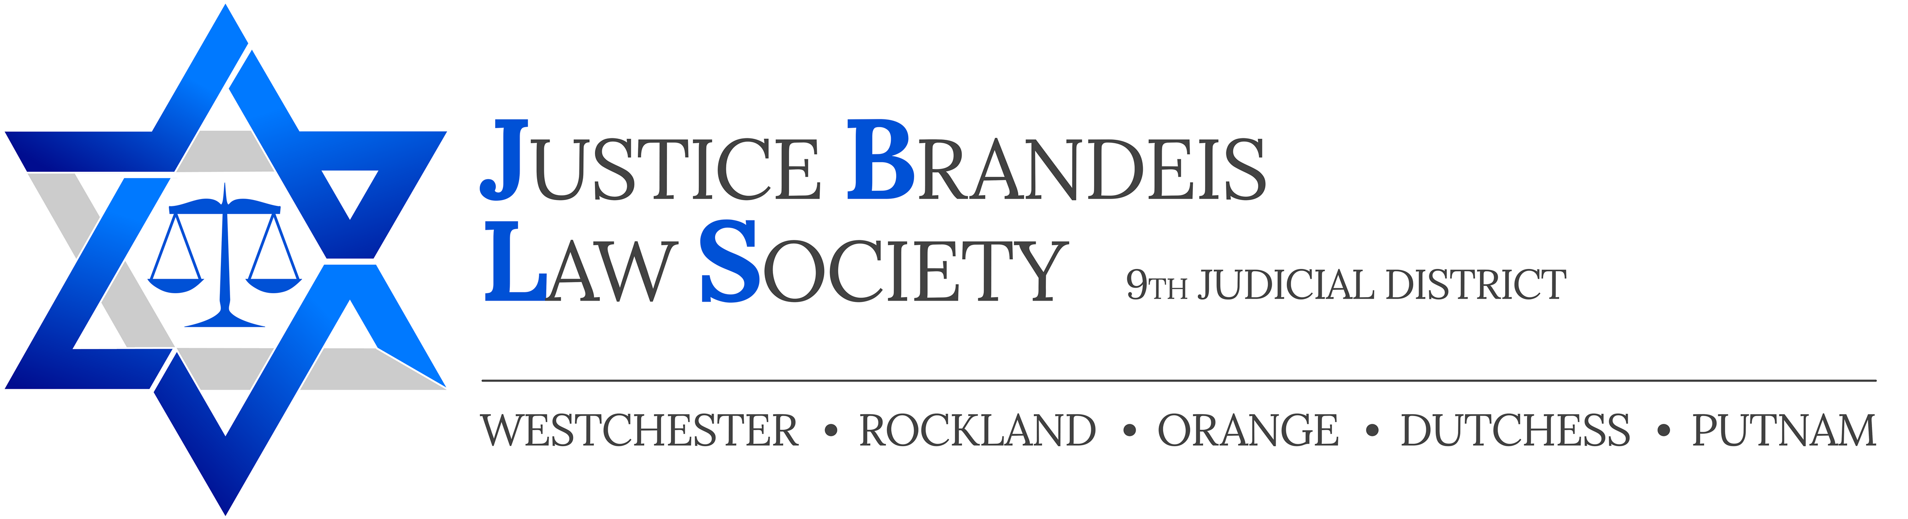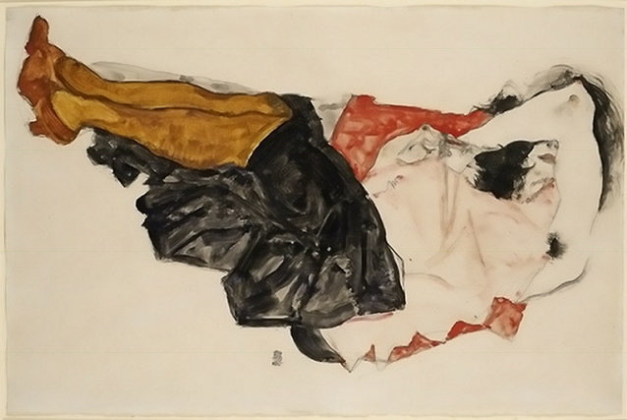

(Woman Hiding Her Face (Egon Schiele 1912)

Click Here for Registration

1 NY CLE credit hour in Professional Practice (upon advance request) courtesy Dunnington, Bartholow & Miller LLP (subject to NYS CLE Board requirements)

